Gosforth Park First School

Document Number

GP-PO-013

Document Name

GPFS Science Policy

Version Number

V 01

Version Control

|  |  |  |  |  |
| --- | --- | --- | --- | --- |
| Document | Version | Date | Author | Change Description |
| GP-PO-013 | 01 | 17/01/2022 | James Hindess | Document release in QMS format |
|  |  |  |  |  |
|  |  |  |  |  |

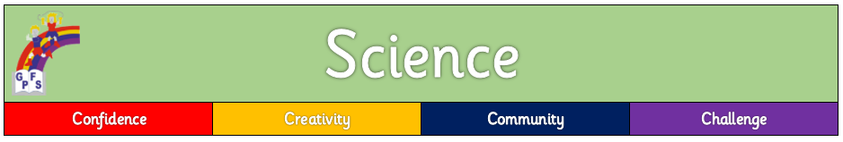

# Purpose of Study

A high-quality science education provides the foundations for understanding the world through the specific disciplines of biology, chemistry and physics. Science has changed our lives and is vital to the world’s future prosperity, and all pupils should be taught essential aspects of the knowledge, methods, processes and uses of science. Through building up a body of key foundational knowledge and concepts, pupils should be encouraged to recognise the power of rational explanation and develop a sense of excitement and curiosity about natural phenomena. They should be encouraged to understand how science can be used to explain what is occurring, predict how things will behave, and analyse causes.

# Aims

To enable children to:

* develop skills to work scientifically while deepening their substantive knowledge acquisition
* develop a systematic and logical way of working
* carry out independent, open scientific enquiry
* deepen their understanding of scientific concepts and models
* work safely and carefully

# Curriculum intent

In Science we aim to give all children a strong understanding of the world around them. They are able to discover how the world works and our place, impact, roles and responsibilities within our environment. Our children are encouraged to ask questions and apply their growing scientific knowledge to investigate and learn more. The children are able to develop a systematic and logical way of working and are able to reflect on investigations and apply their growing knowledge. Science allows children to be inquisitive in a safe environment. It will help develop knowledge rich, confident, articulate and investigative learners.

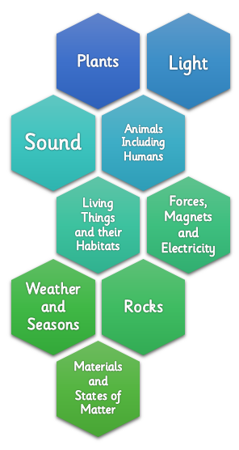

# Teaching and Learning

All children have access to the Early Years Foundation Stage Curriculum and Science National Curriculum. At Gosforth Park we use a long term Science curriculum plan delivered over a two year cycle to ensure that all units are covered. Our plans show the breadth of study as well as how ‘Working Scientifically’ is embedded within each unit of work, through duel objectives. Scientific vocabulary is explicitly taught with each unit of work to enable children to articulate scientific concepts clearly and precisely.

# Curriculum enrichment

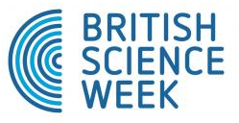We ensure that children have access to a wide range of educational experiences outside of school through trips and links with schools within the Gosforth Schools Trust (GST). We celebrate national science week annually and invite visitors, speakers, companies leading workshops in order to inspire learning.

# Working Scientifically

Working Scientifically is always taught through and clearly related to the programme of study, through duel learning objectives. Pupils at Gosforth Park learn to use a variety of approaches to answer relevant scientific enquiries by classifying, designing experiments and making conclusions. Duel objectives are planned for all science lessons to ensure that children are working scientifically alongside acquiring and remembering new substantive knowledge.

Children use different types of enquiry within each science unit of learning:

* **Classifying and grouping**



* **Researching**
* **Comparative and fair testing**
* **Observing over time**
* **Pattern seeking**

Through this approach we aim to develop the following skills:

observing, raising questions, predicting, hypothesising, planning, controlling factors (fair testing), measuring, collecting and interpreting data, constructing tables and graphs, explaining, communicating and evaluating findings, researching information.

# Progression

Our science curriculum planning enables children to gain an increasingly deeper level of knowledge, understanding and skill competency as they move throughout the school.

* **Knowledge Organisers** are used as a means of arranging important substantive information for our children to refer to and remember.
* **Science Progression Documents** have been developed for Designing Experiments, Classifying, Writing Explanations, Drawing Graphs and Making Conclusions. We use these to ensure planning builds upon prior knowledge and skills.

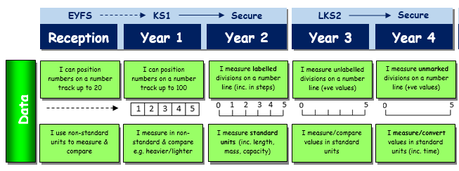

* The National Curriculum and Early Years Foundation Stage curriculum objectives are carefully **mapped and sequenced** as part of our whole-school curriculum journey.
* 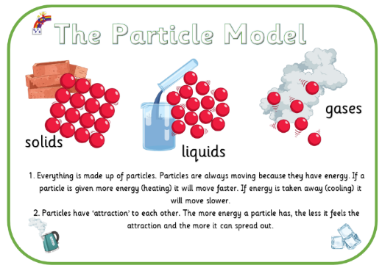Tasks and learning opportunities are planned relating to the **school’s curriculum drivers** (4Cs: confidence, community, creativity and challenge)
* **Scientific concepts** are introduced, learned and used to deepen understanding within relevant learning units. The learning of concepts helps our children to make links between different scientific knowledge and phenomenon across the curriculum.

# Records and Assessment

Assessment of children's development is made through a combination of frequent low-stakes quizzing, end of unit tests and ongoing teacher assessment. Teachers use the working scientifically progression statements to make judgements about current attainment. Knowledge organisers are used to record current attainment within exercise books. Progress and achievement in Science is reported to parents through end of year reports and during autumn and spring parent meetings.

# Safety

It is important that children are taught the rules of safety when undertaking experiments and investigations. Materials and equipment are handled sensibly and we ensure that children are shown the correct way to conduct experiments and work safely. It is the teacher’s responsibility to make sure that all other adults (teaching assistants, parents etc.) are aware of safety implications connected with any Science activity that they are undertaking.

# Monitoring

The Science curriculum is monitored regularly by the science co-ordinator through staff meetings, observation of teaching, monitoring of medium term plans, children’s work and pupil voice.

# Resources

Our science resources are carefully itemised and regularly audited by our Science Coordinator. Resources are organised according to Key Stage learning units in order for them to be easily accessible.