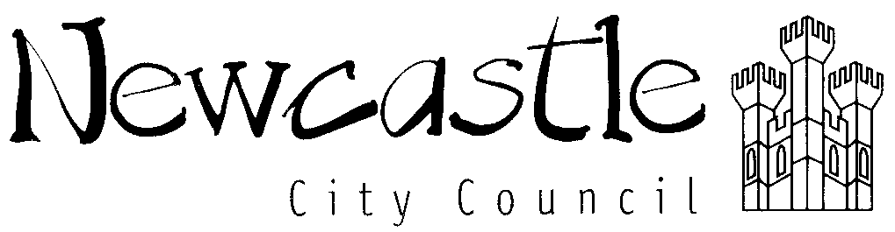 | Parental Consent for a School Visit EV7

School/Group: Gosforth Park First School Year 4

- Details of visit to: Robinwood Activity Centre, Barhaugh Hall, Alston

From: 19/03/2025 Date/Time: 9:15 am. To: 21/03/2025 Date/Time: 15.00 approx

I agree to (name) (date of birth)

taking part in this visit and have read the brochure information sheet. I agree

to ______________’s participation in the activities described. I acknowledge the need

for _____________ to behave responsibly and agree to meet the costs of early return

should such an action be necessary as a result of (name of child)

unacceptable behaviour

I will inform the Group Leader (Mr Hindess) as soon as possible of any changes either medically or other circumstances between now and the commencement of the journey.

4 Declaration

I agree to my child receiving medication as instructed and if necessary to be

given Calpol 6+ or Nurofen if they have a temperature or headache.

Please circle preference.

Address: _________________________________________________________________

_________________________________________________________________

_________________________________________________________________

Telephone number: Home ______________________ Mobile ______________________

Signed: _______________________________ Date: ____________________________

Full name (capitals): _________________________________________________________

THIS FORM WILL BE TAKEN BY THE GROUP LEADER ON THE VISIT.
A COPY WILL BE RETAINED BY SCHOOL

