Gosforth Park First School

Document Number

GP-PO-020

Document Name

GPFS English Policy

Version Number

V 03

Version Control

|  |  |  |  |  |
| --- | --- | --- | --- | --- |
| Document | Version | Date | Author | Change Description |
| GP-GB-PO-013 | 03 | 11/10/2021 | Claire Lambert  Governing Body | Reviewed by Claire Lambert |
| GP-GB-PO-013 | 03 | 16/11/2020 | Claire Lambert  Governing Body | Reviewed by Claire Lambert |
| GP-GB-PO-013 | 02 | 14/10/2019 | Claire Lambert  Governing Body | Reviewed by new English Lead |
| GP-GB-PO-013 | 01 | 20/11/2017 | Governing Body | Document release in QMS format |
|  |  |  |  |  |

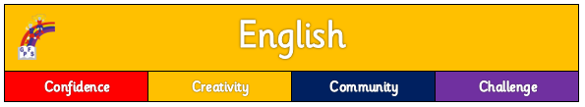

# Purpose of Study

English has a pre-eminent place in education and in society. A high-quality education in English will teach pupils to speak and write fluently so that they can communicate their ideas and emotions to others, and through their reading and listening, others can communicate with them. Through reading in particular, pupils have a chance to develop culturally, emotionally, intellectually, socially and spiritually. Literature, especially, plays a key role in such development. Reading also enables pupils both to acquire knowledge and to build on what they already know. All the skills of language are essential to participating fully as a member of society; pupils who do not learn to speak, read and write fluently and confidently are effectively disenfranchised.

# Aims

To enable children to:

* read easily, fluently and with good understanding
* develop the habit of reading widely and often, for both pleasure and information
* acquire a wide vocabulary, an understanding of grammar and knowledge of linguistic conventions for reading, writing and spoken language
* appreciate our rich and varied literary heritage
* write clearly, accurately and coherently, adapting their language and style in and for a range of contexts, purposes and audiences
* use discussion in order to learn; they should be able to elaborate and explain clearly their understanding and ideas
* are competent in the arts of speaking and listening, making formal presentations, demonstrating to others and participating in debate

# Curriculum Intent

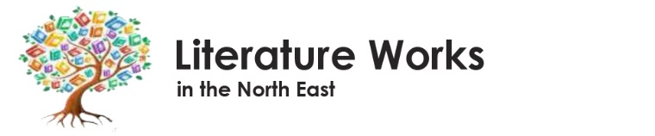At Gosforth Park First School, the teaching of English follows the programmes of study set out in the National Curriculum. It is rooted in the Literature Works approach. Quality engaging children’s literature is chosen to support and extend progress in reading and provide writing opportunities across a range of genres and forms. Opportunities for teachers to enhance pupils’ vocabulary and understanding of English grammatical conventions arise naturally from this creative, stimulating and engaging approach to reading and writing.

***“School life is built around the four Cs: confidence, challenge, creativity and community. Teachers have high expectations of pupils and they rise to the challenge.”***

(DfE, Ofsted report, GPFS, 2020)

English is carefully planned to closely link to our wider school curriculum in order to build on and further develop children’s understanding.

***“The curriculum is planned carefully to help pupils build knowledge on what they already know. Pupils are beginning to make links between subjects to deepen their understanding. For example, in Year 2, pupils have discussed environmental issues in English and they can apply this knowledge in geography.”***(DfE, Ofsted report, GPFS, 2020)

We put reading for pleasure and developing lifelong readers at the heart of our approach. We support our children to access a wide range of poems, stories and non-fiction at a level beyond that at which they can read independently.

The National Curriculum clearly states that all children need to be taught to write clearly, accurately and coherently, adapting their language and style in and for a range of contexts, purposes and audiences. Teachers use the National Curriculum and refer to appendices to ensure curriculum coverage. These National Curriculum objectives are adapted to be child friendly and used as titles in books. Children select the appropriate form and draw independently on what they have read as models for their own writing.

Phonics and Early Reading are the foundations of our English teaching. Phonics and Early Reading is taught using the new Little Wandle Letters and Sounds programme.

National Curriculum year group objectives for phonics, word work, spelling, punctuation and grammar (GDS) are taught directly and applied in context in the English planning linked with whole class texts. The Twinkl scheme is used for GPS progression, spelling and handwriting.

# Teaching and Learning

Quality questioning and discussion forms the introduction to texts at Early Years Foundation Stage (EYFS) and KS1 using the “See, Notice, Wonder” framework to elicit responses and understanding. Using question stems - who, what, when, where, why and how - further develops and deepens understanding.

**Key Stage One:**

**Year 1:**

English unit planning in Year 1 will ensure pupils are given a range of opportunities to:

* Say
* Read
* Write
* Sequence
* Re-read & check
* Discuss
* Read aloud and share their work

**Key Stage One:**

**Year 2:**

English unit planning in Year 2 will ensure pupils are given opportunities to consider what they are going to write by:

In addition, in Year 2 children are taught to make simple additions, revisions and corrections to their own writing by:

* Planning or saying out loud
* Writing down ideas and/or key words, including new vocabulary
* Encapsulating what they want to say, sentence by sentence

**Year 2**

* Evaluating their writing with the teacher and other pupils
* Re-reading to check that their writing makes sense
* Proof-reading to check for errors in spelling, grammar and punctuation
* Making simple corrections in green pencil

When planning a new unit of writing, KS2 teachers use Purpose, Audience, Layout (PAL). An awareness of purpose, audience and layout means that children can be supported to understand how to make choices about their writing.

**Purpose** – why am I writing this? (E.g. to inform, entertain, persuade, tell, recount, report, explain)

**Audience** – who is going to read it? (E.g. just yourself, an individual, larger group)

**Layout** – how am I going to set it out and what language will you us? E.g. what are the key language and grammatical features of this genre?)

**Lower Key Stage Two:**

**Year 3 and 4:**

English unit planning in Year 3 & 4 will engage children in a broad range of writing opportunities. Strategies will include close reading, quality textual analysis and drama activities across a range of media. The planned unit should show evidence of children progressing in skills of:

* Oracy and vocabulary development
* Reading
* Planning their writing
* Textual analysis
* Editing and improving
* Peer and self-assessment
* Grammar, punctuation and spelling

**Lower Key Stage Two:**

**Year 3 and 4:**

The writing process will show pupils:

* planning their writing
* discussing writing similar to that which they are planning to write in order to understand and learn from its structure, vocabulary and grammar
* discussing and recording ideas

Children will draft and write by:

* organising paragraphs around a theme
* in narratives, creating settings, characters and plot
* in non-narrative material, using simple organisational devices [for example, headings and sub-headings]

Evaluate and edit by:

* assessing the effectiveness of their own and others’ writing and suggesting improvements
* proof-read for spelling and punctuation errors

**English Unit Planning - Steps for Success:**

1. Start each new unit of work with discussion of the new unit and introduction of key vocabulary and concepts (PAL)
2. Include a reading objective in each unit
3. Give children opportunities to re-read, check and share their work
4. Work towards a clear end of unit extended writing outcome shared at the outset
5. Share examples of the writing genre, WAGOLL

A typical learning journey in KS2 **could** look like this:

1. Beginning - Discussion and understanding of the purpose, audience and layout of the new genre
2. Oracy skills- opportunities to explore key vocabulary in the new genre
3. WAGOLL, (What a good one looks like - quality textual analysis – finding key features)
4. Creative drama opportunities e.g. hot seating, role play, freeze frame
5. Lesson sequenced and planned to build up the knowledge and skills needed for the final writing outcome
6. Children editing and improving according to teachers’ verbal and written feedback
7. End of Unit – a clear piece of extended writing

# Reading, Phonics and Spelling

***“From Nursery, children quickly learn their letters. They enjoy hearing stories and taking books home to share. From the beginning of Reception, no time is lost in helping children learn to read. Teachers are well trained in the teaching of phonics. They intervene quickly if a child is at risk of falling behind.”***

*(DfE, Ofsted report, GPFS, 2020)*

**EYFS and Year 1**

1. Phonics is taught daily using the **Little Wandle Letters and Sounds Scheme**. Phonic books are used in sessions to record work, build up evidence and show progress
2. Reading is taught 3 times per week focussing on: decoding, prosody, comprehension
3. Online links to books explicitly linked to the child’s phonetic ability are shared with parents
4. A read for pleasure book is taken home weekly
5. Spellings are integrated in the Little Wandle scheme
6. Our aim is for **all** children to have passed the Phonics Screen at the **end of year 1.**
7. Little Wandle Assessments are completed termly and children re-grouped accordingly

*All children working below age group expectations use the Little Wandle keep up and catch up sessions.*

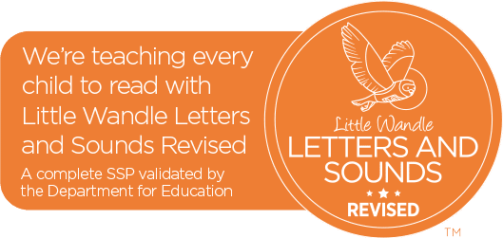

**Year 2**

Reading is taught via whole class reading 3 times per week. Grammar, Punctuation and Spelling (GPS) is taught daily using the Twinkl progression documents, 10 spellings are sent home weekly.

**Key Stage 2**

1. Lessons follow the ‘reading-into-writing’ process. There are three 20-minute spelling and grammar sessions per week.
2. 10 Spellings are sent home weekly and tested. Spelling rules are taught weekly linked to the Twinkl progression documents.
3. Spelling diagnostic assessments are used half-termly.

**Handwriting**

1. Handwriting in EYFS and Year 1 follows the Little Wandle scheme of learning
2. Handwriting in Year 2, Year 3 and Year 4 follows the Twinkl scheme of learning
3. All staff consistently model the correct handwriting formation during any shared or guided writing.

**Quality texts**

English unit planning is based on quality texts sequenced and planned across school. These shared class books should form an integral part of English planning in reading, writing and grammar and should also give an opportunity to link to year group objectives and the wider curriculum. Seeing these features in context should help to embed grammar further. These books can also be used in whole class guided reading sessions.

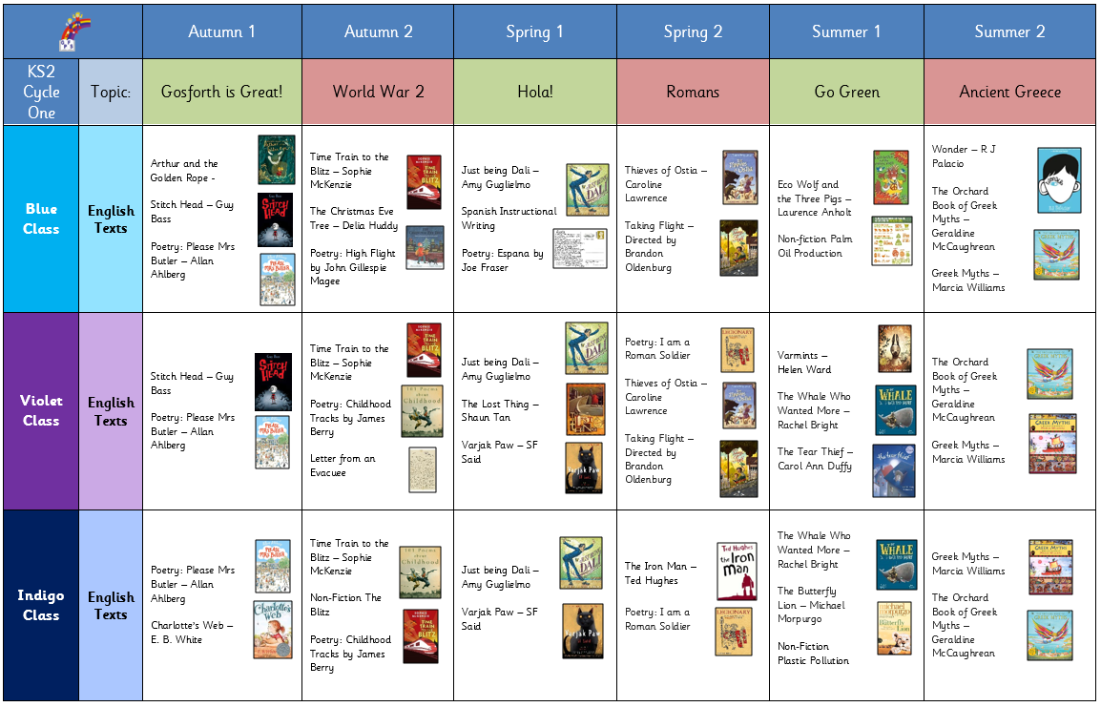

**Reading in KS2**

1. We use the National Curriculum for reading and refer to appendices to ensure coverage.
2. Whole-class reading is planned as 2 week blocks of work using reading objectives from the National Curriculum. These will be based around a quality class text.
3. Whole class reading is taught a minimum of 3 sessions per week.
4. Children not at the expected book band level in KS2 will access **additional** support sessions as well as the whole class guided reading sessions.

**Non-Fiction**

All year groups use a wide range of non-fiction texts to support their English objectives and to link to a range of other curriculum areas, for example Science or History.

**Poetry**

Children explore a wide variety of poems and verse linked to the National Curriculum Objectives.

**Reading at Home**

We encourage all pupils to read frequently at home. Reading diaries are used to record parental engagement in home reading. Teachers check the diaries regularly to see how often pupils are reading at home and use parent 1-1s to encourage less frequent readers.

The Oxford Reading Buddy scheme is available for children in years 2 - 4 (children in Reception and KS1 use the Big Cat phonics online e-reader).

# Records and Assessment

Assessment of children's development in English is made through a combination of ongoing teacher (formative) assessment, frequent low-stakes quizzing and summative assessments (e.g. EYFS baseline, Year 2 SATS). Attainment is recorded at three data-drops throughout the year. Judgements are confirmed between the headteacher, Special Needs Coordinator (SENCO) and class teacher during termly pupil progress meetings. Progress and achievement in English are reported to parents through end of year reports and during autumn and spring parent consultation meetings.

# Monitoring

The English curriculum is monitored regularly by the English co-ordinator through staff meetings, observation of teaching, monitoring of medium term plans, children’s work and pupil voice.

***At Gosforth Park First School,***

***we love to read!***