Language items | Symbol
Activities/Leisure | 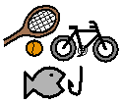
Add (plus) | 
Adult | 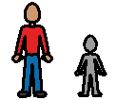
Aeroplane | 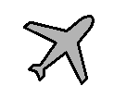
Afraid | 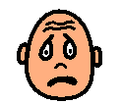
After | 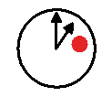
Afternoon | 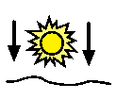
Again | 
All gone | 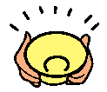
Am | 
Ambulance | 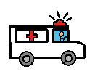
And | 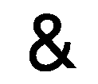
Angry | 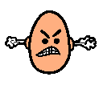
Animals | 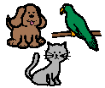
Ant | 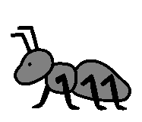
Apple | 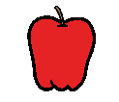
Apple juice | 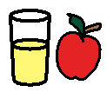
April | 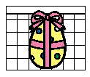
Apron | 
Arm | 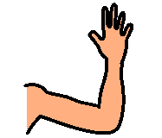
Arts and Crafts | 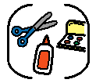
Assembly | 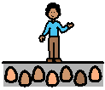
At | 
August | 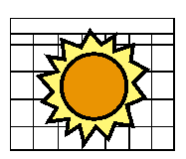
Aunty | 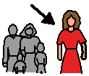
Autumn | 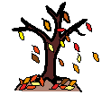
Avocado | 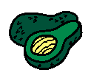
Baby | 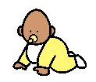
Bad | 
Baked beans | 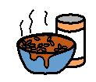
Ball Pool | 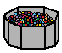
Banana | 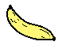
Baptism | 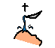
Bath | 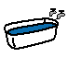
Bathroom | 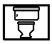
Be quiet | 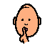
Beach | 
Beans | 
Bear | 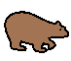
Because | 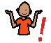
Bed | 
Bedroom | 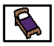
Bee | 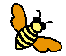
Before | 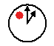
Behaviour | 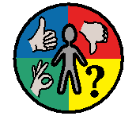
Behind | 
Beside | 
Best | 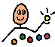
Between | 
Big | 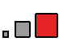
Bike | 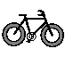
Bird | 
Birthday | 
Biscuit | 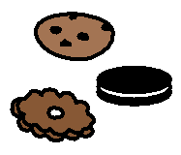
Blackboard | 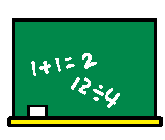
Blackcurrant juice | 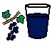
Blouse | 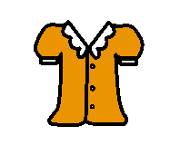
Blue | 
Board game | 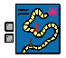
Boat | 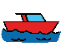
Body awareness | 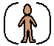
Bonfire night | 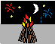
Book time | 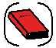
Boots | 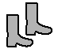
Bored | 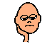
Bottom | 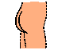
Bottom (position) | 
Bowl | 
Bowling | 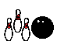
Box time | 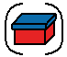
Boy | 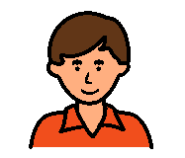
Bra | 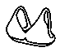
Bread | 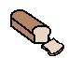
Break time | 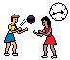
Breakfast | 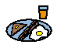
Bridge | 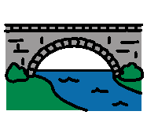
Broccoli | 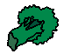
Broken | 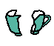
Bronze | 
Bronze | 
Brother | 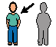
Brown | 
Brown sauce | 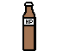
Brush | 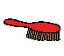
Brush hair | 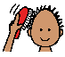
Brush teeth | 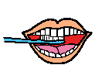
Bubbles | 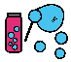
Bungalow | 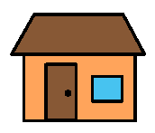
Bus | 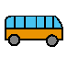
But | 
Butter | 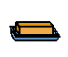
Butterfly | 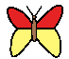
Buy | 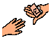
Bye | 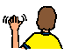
Cabbage | 
Café | 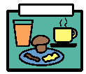
Calendar | 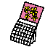
Call | 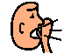
Calm down | 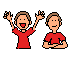
Can | 
Can I? | 
Cap | 
Caravan | 
Card (birthday) | 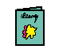
Card (construction paper) | 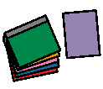
Cardboard | 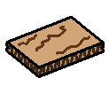
Cardigan | 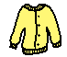
Careers | 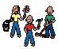
Caretaker | 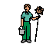
Carrot | 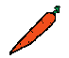
Carry | 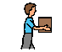
Cat | 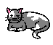
Catch | 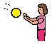
Caterpillar | 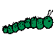
Cauliflower | 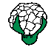
CD | 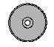
Celebration | 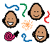
Cereal | 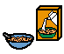
Chair | 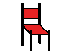
Cheat | 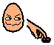
Cheese | 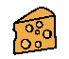
Chicken | 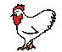
Chicken nuggets | 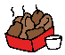
Child | 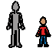
Chips | 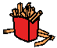
Chocolate | 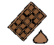
Chocolate bar | 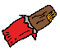
Chocolate milk | 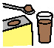
Chocolate mousse | 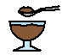
Chocolate spread | 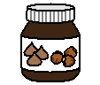
Choice time | 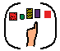
Choose | 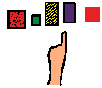
Choose a book | 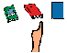
Christmas | 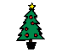
Church | 
Cinema | 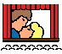
Circle | 
Circle time | 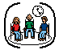
Class | 
Class room | 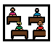
Clean (Verb) | 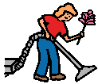
Clean (Description) | 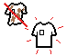
Clever | 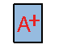
Climb | 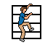
Clothes | 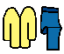
Cloudy | 
Coat | 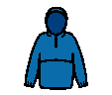
Coffee | 
Cold | 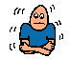
College | 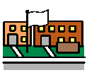
Come | 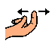
Communication board | 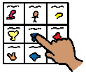
Communication | 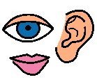
Computer lesson | 
Computer | 
Computer room | 
Confused | 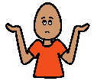
Cook(verb) | 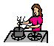
Cook | 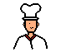
Cooker | 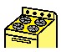
Corner | 
Corridor | 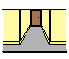
Country | 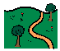
Crayon | 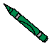
Crayons | 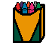
Creative Arts | 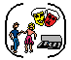
Crisps | 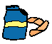
Crocodile | 
Cross (feelings) | 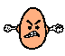
Cross (religious symbol) | 
Crunchy | 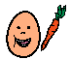
Cry | 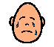
Cube | 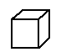
Cup | 
Custard | 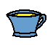
Cut | 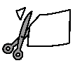
Cycle | 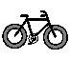
Cocktail juice | 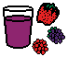
Dad | 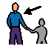
Dance | 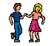
Dance (lesson) | 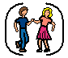
Daughter | 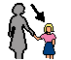
Day | 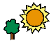
December | 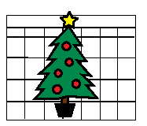
Dentist | 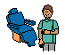
Design technology | 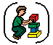
Dice | 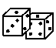
Different | 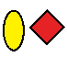
Difficult | 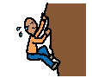
Dining | 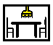
Dinner hall, dining hall | 
Dinner | 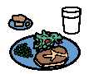
Dinner time | 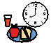
Dinosaur | 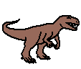
Dirty
Disappointed | 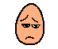
Do | 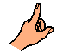
Doctor | 
Dog | 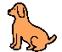
Doll | 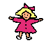
Don't | 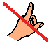
Don't like | 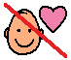
Don't want | 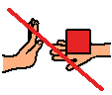
Door | 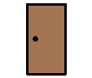
Doughnut | 
Down | 
Drama | 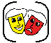
Draw | 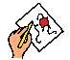
Dress | 
Dressing gown | 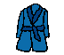
Dressing up | 
Drink | 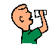
Drink | 
Dry | 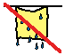
Duck | 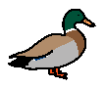
DVD | 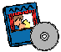
Ear | 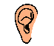
Easter | 
Eat | 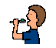
Egg | 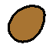
Elephant | 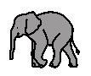
Embarrassed | 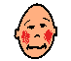
Emotions | 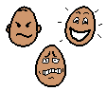
Empty | 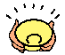
English lesson | 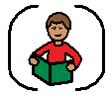
Enrichment | 
Enterprise | 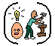
Evening | 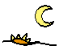
Everyone | 
Excited | 
Exercise | 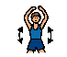
Eye | 
Face cloth | 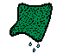
Farm | 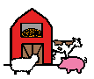
Farm Animals | 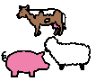
Farmer | 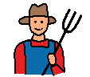
Fast | 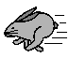
Favourite | 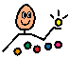
February | 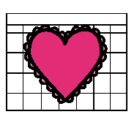
Ferry | 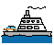
Field | 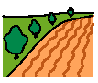
Find | 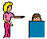
Fire engine | 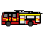
Fireman | 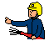
First | 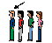
Fish | 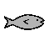
Fish cakes | 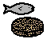
Fish fingers | 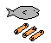
Flour | 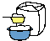
Flower | 
Fly | 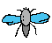
Foggy | 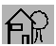
Food | 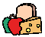
Food technology lesson | 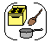
Food technology room | 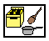
Foot | 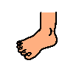
Football | 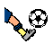
Fork | 
French | 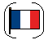
Friday | 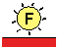
Fridge | 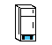
Fried egg | 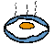
Friend /  Friends | 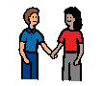
Frightened | 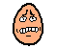
Frog | 
From | 
Frosty | 
Fruit | 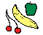
Fruit juice | 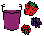
Full | 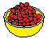
Fun | 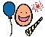
Funny | 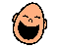
Future | 
Flan | 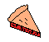
Games | 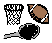
Garden (secret) | 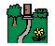
Gents | 
Geography | 
Get | 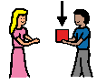
Get dressed | 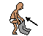
Get undressed | 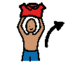
Giraffe | 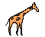
Girl | 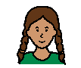
Give | 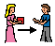
Gloves | 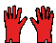
Glue | 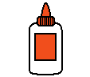
Go | 
Gold | 
Gold | 
Good | 
Good afternoon | 
Good morning | 
Granddad | 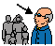
Grandma | 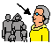
Grapefruit | 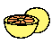
Grapes | 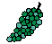
Grass | 
Green | 
Grey | 
Gymnastics | 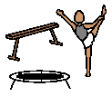
Green beans | 
Hair | 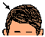
Hall | 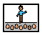
Halloween | 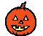
Hamburger | 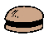
Hamster | 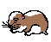
Hand | 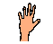
Hands down | 
Happy | 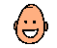
Hard | 
Hat | 
Have | 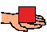
He | 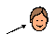
Head | 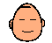
Headache | 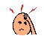
Head teacher | 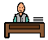
Heavy | 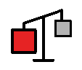
Helicopter | 
Hello | 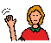
Help | 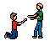
Help Makaton | 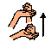
Hen | 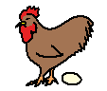
Her | 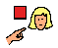
Here | 
Hill | 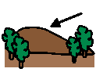
Hippo | 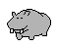
His | 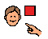
History | 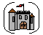
Home (House) | 
Home Time | 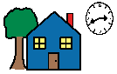
Honey | 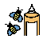
Horse | 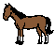
Horse riding | 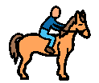
Hospital | 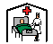
Hot | 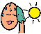
Hot air balloon | 
Hot chocolate | 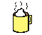
Hot dog | 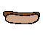
How | 
Hug | 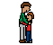
Humanities | 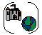
Hungry | 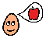
Hurt | 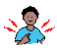
I | 
I don't understand
I hear | 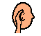
I know | 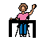
I need | 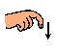
I need my communication book/talker
I see (see) | 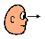
I want (want) | 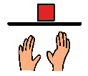
I want to ask you Something | 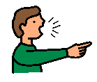
Ice cream | 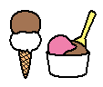
Ice cream cone | 
ICT | 
IT suite | 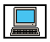
Icy | 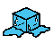
Idea | 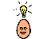
If | 
In | 
In front | 
Independence | 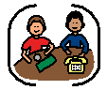
It | 
Jam | 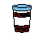
January | 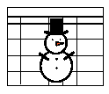
Jeans | 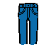
Jigsaw | 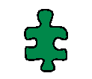
Joke | 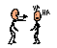
July | 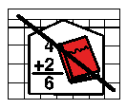
Jump | 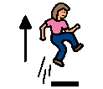
Jumper | 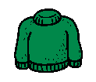
June | 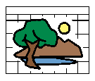
Juice | 
Kind | 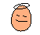
Kiss | 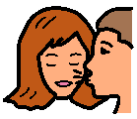
Kitchen | 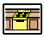
Kitchen staff | 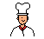
Knee | 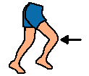
Knickers | 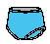
Knife | 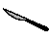
Know | 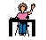
Knowledge and understanding of the world | 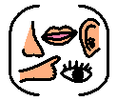
Ketchup | 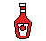
Ladies | 
Ladybird | 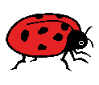
Lamb chop | 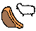
Lasagne | 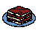
Last | 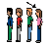
Leaf | 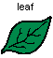
Learn | 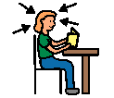
Leave me alone | 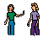
Leaves | 
Lego | 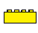
Legs | 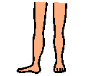
Less | 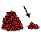
Lesson/  Subject | 
Let me | 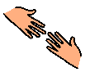
Let's pretend | 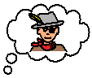
Library | 
Life skills | 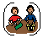
Lift | 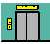
Light | 
Lightning | 
Like /  I like | 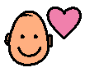
Lion | 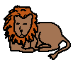
Listen | 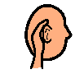
Literacy | 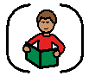
Little | 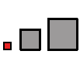
Long | 
Look | 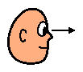
Lorry/  Truck | 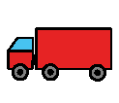
Loud | 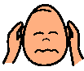
Lounge | 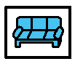
Love | 
Lunch time | 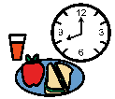
Lunch | 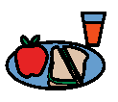
Lunch boards (menu) | 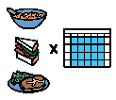
Make | 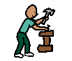
Make (Makaton) | 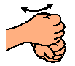
Mam/  Mum/ Mummy/  Mother | 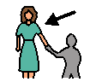
Man | 
March | 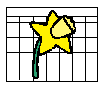
Margarine | 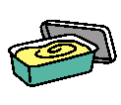
Marmite | 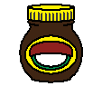
Mash/  Mashed potato | 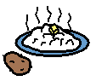
Massage | 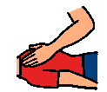
Maths (numeracy) | 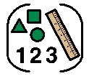
May | 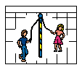
Maybe | 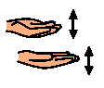
Meat | 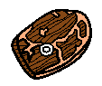
Meatballs | 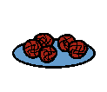
Meeting room | 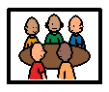
Melon | 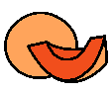
Metro | 
Metro Centre | 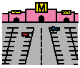
Milk | 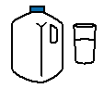
Milkshake | 
Mince | 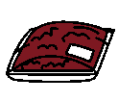
Mine | 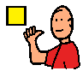
Mistake R | 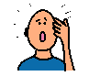
Mix/  Stir R | 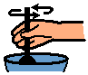
Mobile phone | 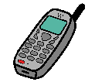
Monday | 
Monkey | 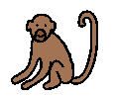
Month | 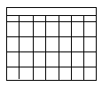
More | 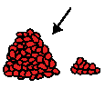
Morning | 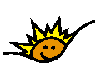
Motor home | 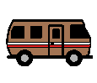
Motorcycle | 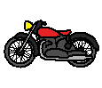
Mouse | 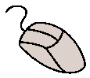
Mouse | 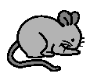
Mouth | 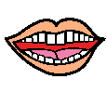
Mushrooms | 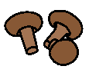
Music | 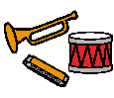
Music | 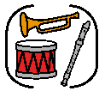
My turn | 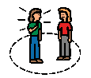
Nasty | 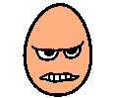
Naughty | 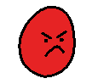
Need | 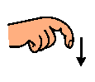
Nest | 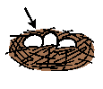
Never | 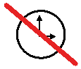
New | 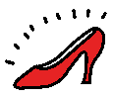
Newcastle NUFC | 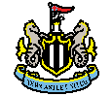
Newcastle | 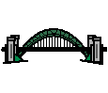
Next | 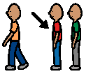
Nice | 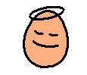
Night | 
Nighty, nightie (night gown) | 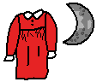
Not | 
No | 
Nose | 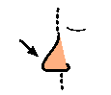
November | 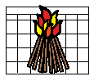
Now | 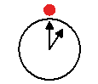
Numeracy | 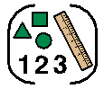
Nurse | 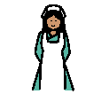
October | 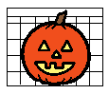
Off | 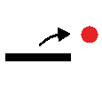
Office | 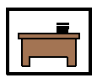
OK | 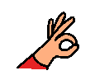
Old | 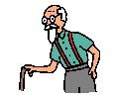
On | 
Onions | 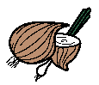
Orange | 
Orange | 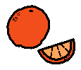
Orange juice | 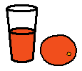
OT/  Occupational therapist/  Occupational therapy | 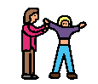
Out | 
Outside | 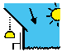
Over | 
Packed lunch | 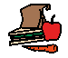
Paints | 
Paint | 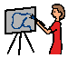
Pale blue | 
Pancakes | 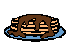
Pants (underwear) | 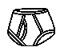
Paper | 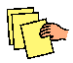
Park | 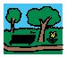
PE | 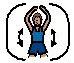
Peach | 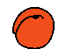
Peanut butter | 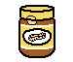
Peas | 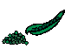
Pen | 
Pencil | 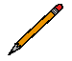
People | 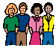
People carrier | 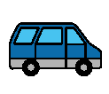
Pepper | 
Physiotherapist | 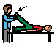
Picture | 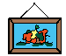
Pig | 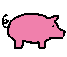
Pineapple | 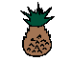
Pink | 
Pizza | 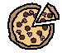
Plate | 
Play | 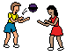
Play station | 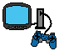
Playground | 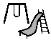
Please | 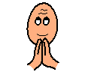
Police car | 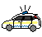
Policeman | 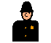
Pond | 
Poo | 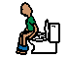
Pop | 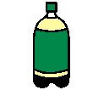
Pork chop | 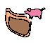
Porridge | 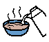
Potato | 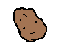
Pour | 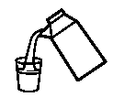
Present | 
Pretty | 
Progress file | 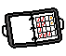
PSHCE | 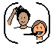
Pudding | 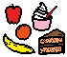
Purple | 
Put | 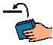
Put (makaton) | 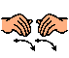
Pyjamas | 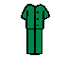
Pastoral time | 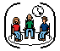
Play time | 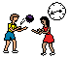
Party | 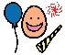
Question | 
Rabbit | 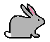
Railway | 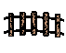
Raincoat | 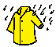
Raining | 
Raisins | 
Rat | 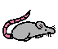
Religious Education | 
Read | 
Read it again | 
Really | 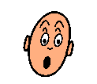
Rebound | 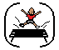
Rectangle | 
Red | 
Register | 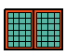
Residential | 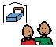
Restaurant | 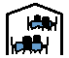
Ribs | 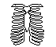
Riding helmet | 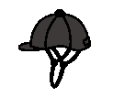
River | 
Road | 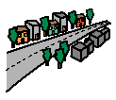
Rocket | 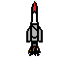
Rough | 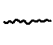
Rubber | 
Ruler | 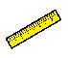
Run | 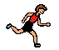
Sad | 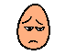
Sailboat | 
Salad | 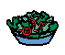
Salt | 
Same | 
Sand play | 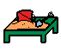
Sandwich | 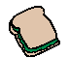
Saturday | 
Sausage | 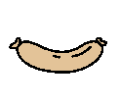
Sausage rolls | 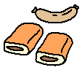
Scared | 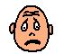
Scarf | 
School | 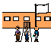
Science | 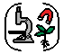
Scissors | 
Scrambled egg | 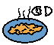
Sea | 
Seal | 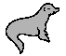
Seasons | 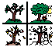
Sensory  Integration room | 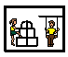
Sensory  Integration | 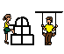
Sensory Room | 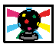
Sensory quad | 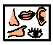
Sensory time | 
September | 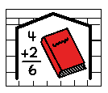
Share | 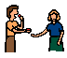
She | 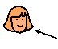
Sheep | 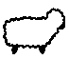
Shiny | 
Shirt | 
Shoes | 
Shop | 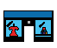
Shop keeper (cashier) | 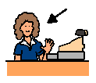
Shopping | 
Short | 
Shorts | 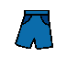
Shower | 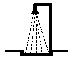
Sick | 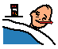
Sign | 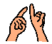
Silly | 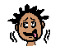
Silver | 
Silver | 
Singing (lesson) | 
Sing | 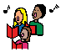
Sister | 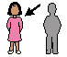
Sit | 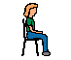
Sit down | 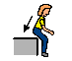
Sixth form | 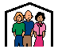
Skateboard | 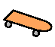
Skirt | 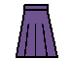
Sleep | 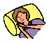
Slippers | 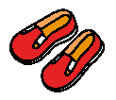
Slow | 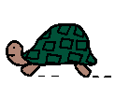
Smart board (white Board) | 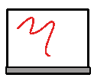
Smelly | 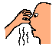
Smile | 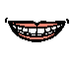
Snack | 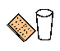
Snack time | 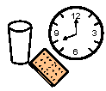
Snake | 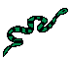
Snap | 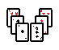
Snowing /  Snowy/  Snow | 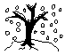
Soap | 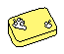
Socks | 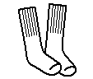
Soft | 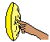
Soft play | 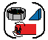
Soft play | 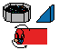
Some | 
[Something] special | 
Sometimes | 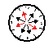
Son | 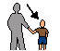
Sorry | 
Soup | 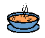
Spaghetti | 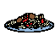
Speak | 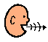
Speech therapist | 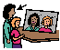
Spider | 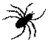
Spiky | 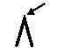
Spoon | 
Spring | 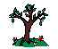
Square | 
Squirrel | 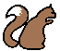
St James Park | 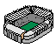
Staff room | 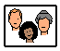
Stand | 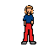
Stand up | 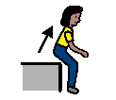
Star | 
Start | 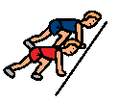
Stomach | 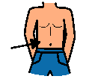
Stop | 
Story | 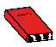
Story time (lesson) | 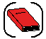
strawberry | 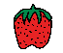
Sugar | 
Sunday | 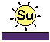
Sunny | 
Supermarket | 
Support worker | 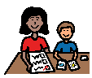
Sweet | 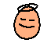
Sweets | 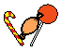
Swim | 
Hydrotherapy (lesson) | 
Swimming pool/  Pool | 
Senses | 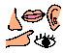
Swing | 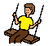
Swiss roll | 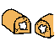
Symbols | 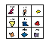
Table | 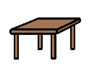
Take | 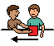
Tall | 
Target | 
Taste | 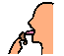
Taxi | 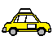
Tea | 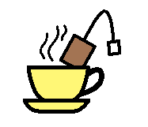
Teacher | 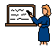
Teddy | 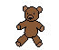
Teeth | 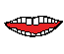
Telephone | 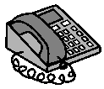
Television | 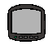
Tell | 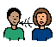
Thank you | 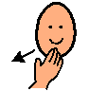
That | 
Theatre | 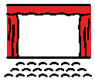
Their | 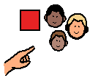
Them | 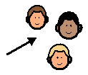
There | 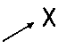
Thing | 
Think | 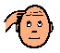
Thirsty | 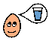
This | 
Throat | 
Thunder | 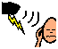
Thursday | 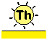
Tickle | 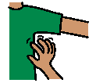
Tidy (clean up) | 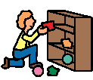
Tights | 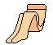
Time | 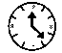
Time out | 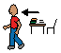
Tired | 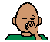
To | 
Toast | 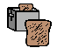
Today | 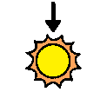
Toes | 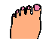
Toilet | 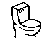
Toilet paper | 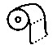
Tomato | 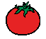
Tomorrow | 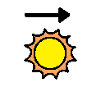
Toothbrush | 
Toothpaste | 
Top | 
Tortoise | 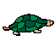
Towel | 
Town
Toy train | 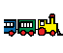
Toys | 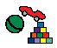
Track suit | 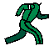
Tractor | 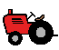
Train | 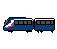
Train station | 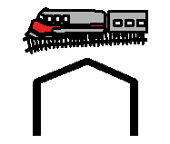
Trainers | 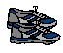
Trampoline | 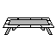
Transport | 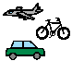
Tree (Elm tree) | 
Triangle | 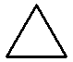
Trousers | 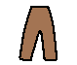
T-shirt | 
Tuesday | 
Tuna | 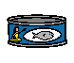
Turn tape | 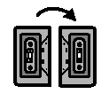
Turn the page | 
Turnip | 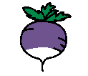
Twiddle toys | 
Tube (Shape) | 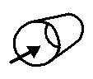
Truck
Uncle | 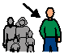
Uncomfortable | 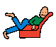
Under | 
Underground | 
Understand | 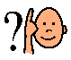
Underwear (boys) | 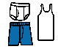
Underwear (girls) | 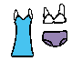
Up | 
Use | 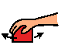
Vegetables | 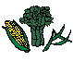
Verbs /  Action words | 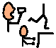
Vest | 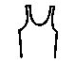
Video | 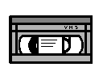
Visit | 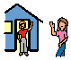
Waffle | 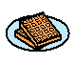
Wait | 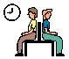
Walk | 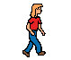
Want | 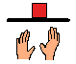
Wash | 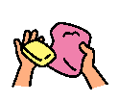
Wash hands | 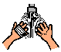
Watch | 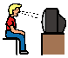
Water | 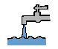
Water play | 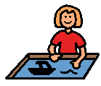
We | 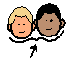
Weather | 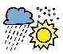
Wednesday | 
Wee | 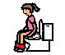
Wee | 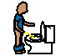
Week | 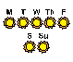
Weekend | 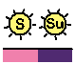
Wet | 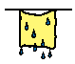
Wet wipes | 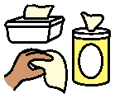
Whale | 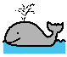
What | 
What's that | 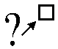
Wheelchair | 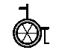
When | 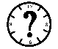
Where | 
Which | 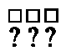
White | 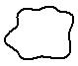
White board
Why | 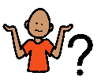
Window | 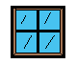
Wind | 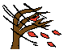
Winter | 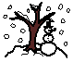
Wipe bottom | 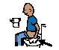
With | 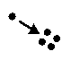
Woman | 
Work experience | 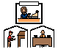
Work time | 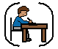
Work | 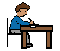
Worm | 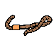
Worried | 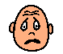
Wrapping paper | 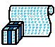
Write | 
Year (calendar) | 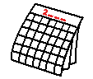
Yellow | 
Yes | 
Yesterday | 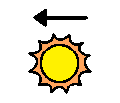
Yoghurt | 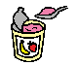
You | 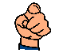
Your / yours | 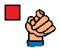
Your turn | 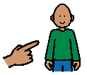
Youth Club | 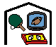
Yuck/y | 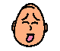
Yummy | 

