Ideas for Music Challenges
Rainbow Music - Learn a song about a rainbow. Some ideas are ...
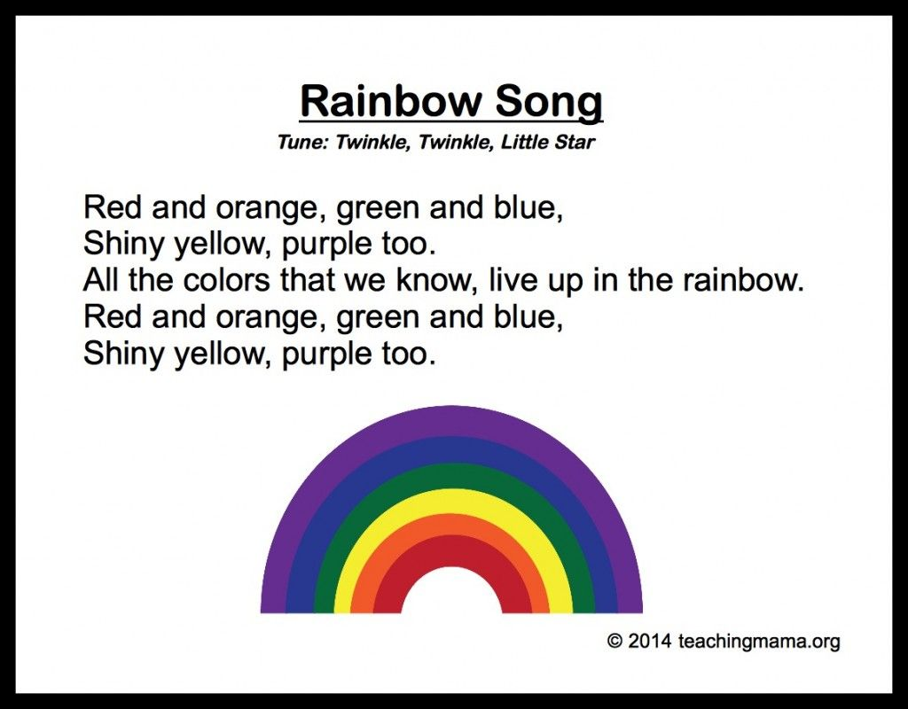

https://www.youtube.com/watch?v=5xlbwSJFDDU Sign language version of Sing a Rainbow
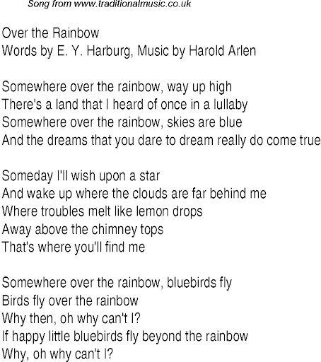
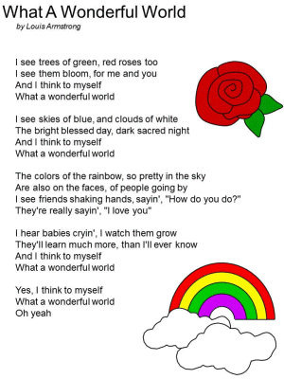

Learn the song and sing it from your window or garden to your neighbours or call a friend or relative to brighten their day.

Instrument Challenge
The Remarkable Farkle McBride by John Lithgow https://www.youtube.com/watch?v=oM5pmq5nr1Q
Watch the video paying careful attention to all the orchestral instruments - how many instruments can you think of that are NOT in this orchestra?

Singing and Signing
Learn a Song with sign language. Here are a few examples but feel free to choose your own.
Gospel Medley - Sing Up
https://www.youtube.com/watch?v=FxPOromTmpE
Believe
https://www.youtube.com/watch?v=BK6J4haWzHI&list=RD5xlbwSJFDDU&index=8
Good to be me
https://www.youtube.com/watch?v=SnI_XRNpDq0&list=RD5xlbwSJFDDU&index=10
Just Like A Roman
https://www.youtube.com/watch?v=lYdoqFmJf6o&list=RD5xlbwSJFDDU&index=13

