If you could have a snack, would you rather…
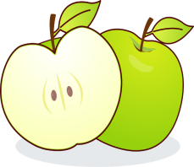 | Or | 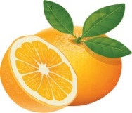
An Apple ☐ |  | An Orange ☐
If you could have a new pet, would you rather…
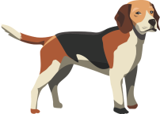 | Or | 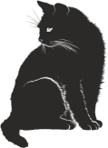
A dog? ☐ |  | A cat? ☐
If you could have a day out, would you rather…
 | Or | 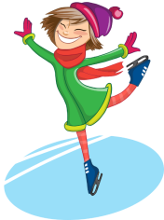
Go to the zoo? ☐ |  | Go ice skating? ☐
If you could stay up late, would you rather…
 | Or | 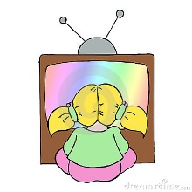
Read a book? ☐ |  | Watch a cartoon? ☐
If you could have something sweet, would you rather…
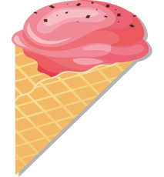 | Or | 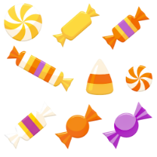
Ice cream ☐ |  | Sweets ☐
Which do you prefer doing,
 | Or
Chatting on the phone ☐ |  | Listening to music ☐
Resource 1 – Would you rather?

