Gosforth Park First School

Document Number
GP-GB-PO-xxx

Document Name
GPFS RSE and PSHE Policy

Version Number
V 01

Version Control
Document | Version | Date | Author | Change Description
GP-GB-PO-xxx | 01 | 04/03/2019 | Dionne McClurg | Document release in QMS format

Contents

1 Aims 3
2 Statutory requirements 3
3 Policy development 3
4 Definition 4
5 Curriculum 4
6 Delivery of RSE 4
7 Roles and responsibilities 6
8 Parents’ right to withdraw 7
9 Training 7
10 Monitoring arrangements 8
Appendix 1: Curriculum map 8
Appendix 2: By the end of primary school pupils should know 17

Aims
The aims of relationships and sex education (RSE) at our school are to:
- Provide a framework in which sensitive discussions can take place
- Give pupils an understanding of the importance of health and hygiene
- Help pupils develop feelings of self-respect, confidence and empathy
- Create a positive culture around issues of relationships
- Teach pupils the correct vocabulary to describe themselves and their bodies

At GPFS we aim to develop resilient, confident and critical readers and thinkers who have the skills for lifelong learning. We believe that children should be exposed to rich creative experiences which celebrate diversity and develop cultural awareness. We promote their spiritual, moral, cultural, mental and physical development in order to best prepare our pupils for the opportunities, responsibilities and experiences of later life. We aim to nurture and foster the kindness and empathy our pupils will need as fulfilled, responsible and educated citizens of the world.

Statutory requirements
As a maintained first school we must provide relationships education to all pupils as per section 34 of the Children and Social work act 2017.
However, we are not required to provide sex education. The elements of sex education contained in the science curriculum are taught when pupils are in middle school.
In teaching RSE, we must have regard to guidance issued by the secretary of state as outlined in section 403 of the Education Act 1996.
At Gosforth Park First School we teach RSE as set out in this policy.

Policy development
This policy has been developed in consultation with staff, pupils and parents. The consultation and policy development process involved the following steps:
- Review – a member of staff collated all relevant information including relevant national and local guidance

- Staff consultation – all school staff were given the opportunity to look at the policy and make recommendations

- Parent/stakeholder consultation – parents and any interested parties were invited to comment on the policy

- Pupil consultation – we investigated what exactly pupils want from their RSE

- Ratification – once amendments were made, the policy was shared with governors and ratified

Definition

Relationships and Sex Education (RSE) is about the emotional, social and cultural development of pupils, and involves learning about relationships, healthy lifestyles, diversity and personal identity.
RSE involves a combination of sharing information, and exploring issues and values.
As a first school we only provide relationships education. RSE is not about the promotion of sexual activity.

Curriculum
Our curriculum is set out as per Appendix 1 but we may need to adapt it as and when necessary.
We have developed the curriculum in consultation with parents, pupils and staff, taking into account the age, needs and feelings of pupils. If pupils ask questions outside the scope of this policy, teachers will seek advice from senior leaders in school.

Delivery of RSE
Our Personal, Social, Health and Economics (PSHE) and RSE education, including statutory Relationships and Health education, as recommended by the DfE, provides a framework though which key skills, attributes and knowledge can be developed and applied. This promotes positive behaviour, good mental health and wellbeing, resilience and achievement, helping children to stay safe online, develop healthy and safe relationships, making sense of media messages, challenging extreme views and having the skills and attributes to negotiate and assert themselves now and in the future.

The school’s PSHE provision supports the school’s aims of developing confident citizens and successful learners who are creative, resourceful and able to identify and solve problems. The social and emotional development of pupils is embedded throughout the entire school’s curriculum and culture. The school has a powerful combination of a planned thematic PSHE program, built around a spiral curriculum of recurring themes, designed to:
  - Give pupils the knowledge and develop the self-esteem, confidence and self-awareness to make informed choices and decisions;
  - Encourage and support the development of social skills and social awareness;
  - Enable pupils to make sense of their own personal and social experiences;
  - Promote responsible attitudes towards the maintenance of good physical and mental health, supported by a safe and healthy lifestyle;
  - Enable effective interpersonal relationships and develop a caring attitude towards others;
  - Encourage a caring attitude towards and responsibility for the environment;
  - Help our pupils understand and manage their feelings, build resilience and be independent, curious problem solvers;
  - Understand how society works and the laws, rights and responsibilities involved.

We know there is a proven link between pupils' health and wellbeing, and their academic progress. Crucial skills and positive attitudes developed through comprehensive Personal, Social, Health and Economic education are critical to ensuring children are effective learners.

Gosforth Park First School has developed a clear and comprehensive PSHE scheme of work in line with the National Curriculum, tailored to our children, using the National PSHE Association for guidance. PSHE is taught as both explicit weekly lessons using the PSHE Scheme of Work; but is also fully embedded in every aspect of our curriculum and day-to-day life of the school. We are also a No Outsiders school and pride ourselves on inclusive education, promoting community cohesion to prepare young people and adults for life as global citizens.

The PHSE programme of study is based on three core themes within which there will be a broad overlap and flexibility:

1. Physical Health and Mental Wellbeing (with particular focus on resilience and emotional wellbeing)
2. Relationships
3. Living in the wider world

RSE is taught within the personal, social, health and economic (PSHE) education curriculum. Biological aspects of RSE are taught within the science curriculum (for example the lifecycle of a frog), and other aspects are included in religious education (RE) such as marriage.
Relationships education focuses on teaching the fundamental building blocks and characteristics of positive relationships including:
- Families and people who care for me
- Caring friendships
- Respectful relationships
- Online relationships
- Being safe

For more information about our RSE curriculum, see Appendices 1 and 2.

These areas of learning are taught within the context of family life taking care to ensure that there is no stigmatisation of children based on their home circumstances (families can include single parent families, LGBT parents, families headed by grandparents, adoptive parents, foster parents/carers amongst other structures) along with reflecting sensitively that some children may have a different structure of support around them (for example: looked after children or young carers).

Roles and responsibilities
7.1 The governing body
The governing body will approve the RSE policy, and hold the headteacher to account for its implementation.
7.2 The headteacher
The headteacher is responsible for ensuring that RSE is taught consistently across the school.
7.3 The PSHE Lead
The PSHE Lead will support colleagues in their teaching by giving them information about current developments in the subject, and by providing a strategic lead and direction for the subject in the school. When using external speakers e.g. health promotion specialists, school nurses, NSPCC, family links – doctors, community police and fire officers, to deliver aspects of our PSHE programme, the PSHE Lead will ensure that these support and benefit our PSHE curriculum and needs of the children in our school. Their input will be carefully planned and monitored so as to fit into and complement the programme. Teachers are always present during these sessions and remain responsible for the delivery of the PSHE programme. These sessions are always in addition to class teaching.
7.4 Staff
Staff are responsible for:
- Delivering RSE in a sensitive way
- Modelling positive attitudes to RSE
- Monitoring progress
- Responding to the needs of individual pupils
Staff do not have the right to opt out of teaching RSE. Staff who have concerns about teaching RSE are encouraged to discuss this with the headteacher.
All class teachers are responsible for teaching RSE in our school. Each class teacher is responsible for delivering the PSHE topics to their class.
7.5 Pupils
Pupils are expected to engage fully in RSE and, when discussing issues related to RSE, treat others with respect and sensitivity.

Parents’ right to withdraw
Parents do not have the right to withdraw their children from relationships education.
Parents do have the right to withdraw their children from the non-statutory/non-science components of sex education within RSE, however these elements are not taught at Gosforth Park and will be taught at middle school.

Training
Staff are trained on the delivery of RSE as part of their induction and it is included in our continuing professional development calendar.
The headteacher will also invite visitors from outside the school, such as school nurses or health professionals, to provide support and training to staff teaching RSE.

Monitoring arrangements
The delivery of RSE is monitored by link governor & PSHE lead, through:
- Book looks
- Monitoring of planning
- Learning walks
- Pupil interviews
Pupils’ development in RSE is monitored by class teachers as part of our internal assessment systems.
This policy will be reviewed by PSHE Lead. At every review, the policy will be approved by the governing body.

Appendix 1: Curriculum map

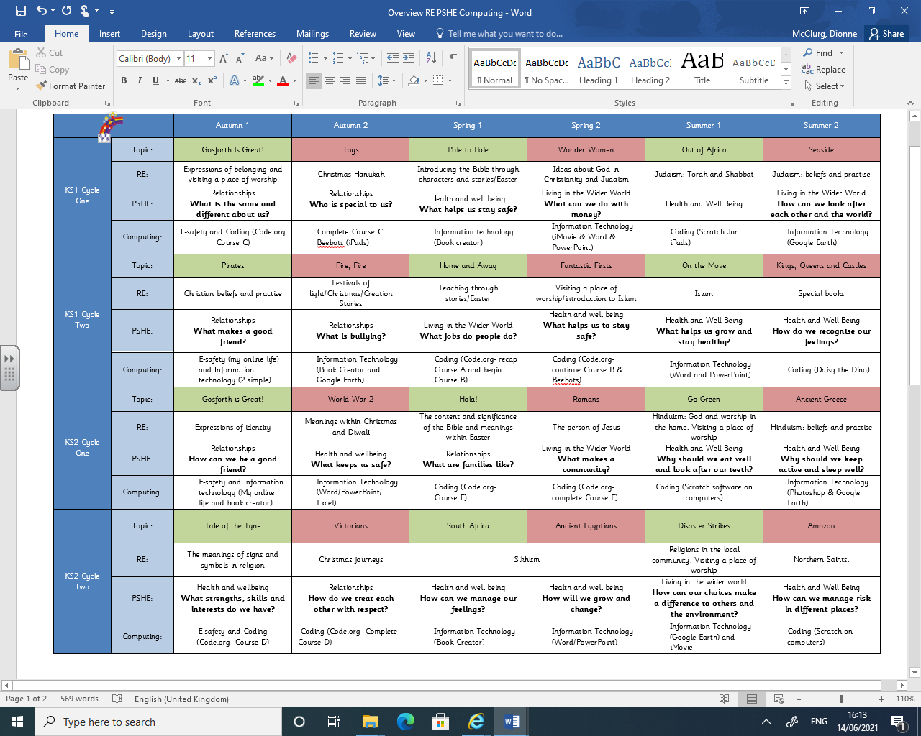
Relationships and sex education curriculum map
Year | Term | Topic/theme details | Resources
Year 1 | Autumn  Spring 1  Summer 1 | What is the same and different about us?  • what they like/dislike and are good at  • what makes them special and how everyone has different strengths  • how their personal features or qualities are unique to them  • how they are similar or different to others, and what they have in common  • to use the correct names for the main parts of the body, including external genitalia; and that parts of bodies covered with underwear are private  Who is special to us?  • that family is one of the groups they belong to, as well as, for example, school, friends, clubs  • about the different people in their family / those that love and care for them  • what their family members, or people that are special to them, do to make them feel loved and cared for • how families are all different but share common features – what is the same and different about them  • about different features of family life, including what families do/ enjoy together  • that it is important to tell someone (such as their teacher) if something about their family makes them feel unhappy or worried  What helps us stay healthy?  • what being healthy means and who helps help them to stay healthy (e.g. parent, dentist, doctor)  • that things people put into or onto their bodies can affect how they feel  • how medicines (including vaccinations and immunisations) can help people stay healthy and that some people need to take medicines every day to stay healthy  • why hygiene is important and how simple hygiene routines can stop germs from being passed on  • what they can do to take care of themselves on a daily basis, e.g. brushing teeth and hair, hand washing  Who helps us to keep safe?  • that people have different roles in the community to help them  (and others) keep safe - the jobs they do and how they help people  • who can help them in different places and situations; how to attract someone’s attention or ask for help; what to say  • how to respond safely to adults they don’t know  • what to do if they feel unsafe or worried for themselves or others; and the importance of keeping on asking for support until they are heard  • how to get help if there is an accident and someone is hurt, including how to dial 999 in an emergency and what to say | PSHE Association
Year 2 | Autumn  Spring 2  Summer | What makes a good friend?  • how to make friends with others  • how to recognise when they feel lonely and what they could do about it  • how people behave when they are being friendly and what makes a good friend  • how to resolve arguments that can occur in friendships  • how to ask for help if a friendship is making them unhappy  What is bullying?  • how words and actions can affect how people feel  • how to ask for and give/not give permission regarding physical contact and how to respond if physical contact makes them uncomfortable or unsafe  • why name-calling, hurtful teasing, bulling and deliberately excluding others is unacceptable  • how to respond if this happens in different situations  • how to report bullying or other hurtful behaviour, including online, to a trusted adult and the importance of doing so  What helps us to stay safe?  • how rules and restrictions help them to keep safe (e.g. basic road, fire, cycle, water safety; in relation to medicines/household products and online)  • how to identify risky and potentially unsafe situations (in familiar and unfamiliar environments, including online) and take steps to avoid or remove themselves from them  • how to resist pressure to do something that makes them feel unsafe or uncomfortable, including keeping secrets  • how not everything they see online is true or trustworthy and that people can pretend to be someone they are not  • how to tell a trusted adult if they are worried for themselves or others, worried that something is unsafe or if they come across something that scares or concerns them  What helps us grow and stay healthy?  • that different things help their bodies to be healthy, including food and drink, physical activity, sleep and rest  • that eating and drinking too much sugar can affect their health, including dental health  • how to be physically active and how much rest and sleep they should have everyday  • that there are different ways to learn and play; how to know when to take a break from screen-time  • how sunshine helps bodies to grow and how to keep safe and well in the sun  How do we recognise our feelings?  • how to recognise, name and describe a range of feelings  • what helps them to feel good, or better if not feeling good  • how different things / times / experiences can bring about different feelings for different people (including loss, change and bereavement or moving on to a new class/year group)  • how feelings can affect people in their bodies and their behaviour  • ways to manage big feelings and the importance of sharing their feelings with someone they trust  • how to recognise when they might need help with feelings and how to ask for help when they need it
Year 3 | Autumn 1  Spring 1  Autumn 2  Summer | How can we be a good friend?  • how friendships support wellbeing and the importance of seeking support if feeling lonely or excluded  • how to recognise if others are feeling lonely and excluded and strategies to include them  • how to build good friendships, including identifying qualities that contribute to positive friendships  • that friendships sometimes have difficulties, and how to manage when there is a problem or an argument between friends, resolve disputes and reconcile differences  • how to recognise if a friendship is making them unhappy, feel uncomfortable or unsafe and how to ask for support  What keeps us safe?  • how to recognise hazards that may cause harm or injury and what they should do to reduce risk and keep themselves (or  others) safe  • how to help keep their body protected and safe, e.g. wearing a seatbelt, protective clothing and stabilizers  • that their body belongs to them and should not be hurt or touched without their permission; what to do and who to tell if they feel uncomfortable  • how to recognise and respond to pressure to do something that makes them feel unsafe or uncomfortable (including online)  • how everyday health and hygiene rules and routines help people stay safe and healthy (including how to manage the use of medicines, such as for allergies and asthma, and other  household products, responsibly)  • how to react and respond if there is an accident and how to deal with minor injuries e.g. scratches, grazes, burns  • what to do in an emergency, including calling for help and speaking to the emergency services  What are families like?  • how families differ from each other (including that not every family has the same family structure, e.g. single parents, same sex parents, step-parents, blended families, foster and adoptive  parents)  • how common features of positive family life often include  shared experiences, e.g. celebrations, special days or holidays  • how people within families should care for each other and the different ways they demonstrate this  • how to ask for help or advice if family relationships are making them feel unhappy, worried or unsafe  Why should we eat well and look after our teeth?  • how to eat a healthy diet and the benefits of nutritionally rich foods  • how to maintain good oral hygiene (including regular brushing and flossing) and the importance of regular visits to the dentist  • how not eating a balanced diet can affect health, including the impact of too much sugar/acidic drinks on dental health  • how people make choices about what to eat and drink, including who or what influences these  • how, when and where to ask for advice and help about healthy eating and dental care  Why should we keep active and sleep well?  • how regular physical activity benefits bodies and feelings  • how to be active on a daily and weekly basis - how to balance time online with other activities  • how to make choices about physical activity, including what and who influences decisions  • how the lack of physical activity can affect health and wellbeing  • how lack of sleep can affect the body and mood and simple routines that support good quality sleep  • how to seek support in relation to physical activity, sleep and rest and who to talk to if they are worried
Year 4 | Autumn 1  Autumn 2  Spring  Summer 2 | What strengths, skills and interests do we have?  • how to recognise personal qualities and individuality  • to develop self-worth by identifying positive things about themselves and their achievements  • how their personal attributes, strengths, skills and interests contribute to their self-esteem  • how to set goals for themselves  • how to manage when there are set-backs, learn from mistakes and reframe unhelpful thinking  How do we treat each other with respect?  • how people’s behaviour affects themselves and others, including online  • how to model being polite and courteous in different situations and recognise the respectful behaviour they should receive in return  • about the relationship between rights and responsibilities  • about the right to privacy and how to recognise when a confidence or secret should be kept (such as a nice birthday surprise everyone will find out about) or not agreed to and when to tell (e.g. if someone is being upset or hurt)*  • the rights that children have and why it is important to protect these*  • that everyone should feel included, respected and not discriminated against; how to respond if they witness or experience exclusion, disrespect or discrimination  • how to respond to aggressive or inappropriate behaviour (including online and unwanted physical contact) – how to report concerns  How can we manage our feelings?  • how everyday things can affect feelings  • how feelings change over time and can be experienced at different levels of intensity  • the importance of expressing feelings and how they can be expressed in different ways  • how to respond proportionately to, and manage, feelings in different circumstances  • ways of managing feelings at times of loss, grief and change  • how to access advice and support to help manage their own or others’ feelings  How can we manage risk in different places?  • how to recognise, predict, assess and manage risk in different situations  • how to keep safe in the local environment and less familiar locations (e.g. near rail, water, road; fire/firework safety; sun safety and the safe use of digital devices when out and about)  • how people can be influenced by their peers’ behaviour and by a desire for peer approval; how to manage this influence  • how people’s online actions can impact on other people  • how to keep safe online, including managing requests for personal information and recognising what is appropriate to share or not share online  • how to report concerns, including about inappropriate online content and contact  • that rules, restrictions and laws exist to help people keep safe and how to respond if they become aware of a situation that is anti-social or against the law  How will we grow and change?  • about puberty and how bodies change during puberty  • how puberty can affect emotions and feelings  • how personal hygiene routines change during puberty  • how to ask for advice and support about growing and changing and puberty

Relationships
Health and wellbeing

Appendix 2: By the end of primary school pupils should know (RSE)
Topic | Pupils should know
Families and people who care about me | - That families are important for children growing up because they can give love, security and stability  - The characteristics of healthy family life, commitment to each other, including in times of difficulty, protection and care for children and other family members, the importance of spending time together and sharing each other’s lives  - That others’ families, either in school or in the wider world, sometimes look different from their family, but that they should respect those differences and know that other children’s families are also characterised by love and care  - That stable, caring relationships, which may be of different types, are at the heart of happy families, and are important for children’s security as they grow up  - That marriage represents a formal and legally recognised commitment of two people to each other which is intended to be lifelong  - How to recognise if family relationships are making them feel unhappy or unsafe, and how to seek help or advice from others if needed
Caring friendships | - How important friendships are in making us feel happy and secure, and how people choose and make friends  - The characteristics of friendships, including mutual respect, truthfulness, trustworthiness, loyalty, kindness, generosity, trust, sharing interests and experiences and support with problems and difficulties  - That healthy friendships are positive and welcoming towards others, and do not make others feel lonely or excluded  - That most friendships have ups and downs, and that these can often be worked through so that the friendship is repaired or even strengthened, and that resorting to violence is never right  - How to recognise who to trust and who not to trust, how to judge when a friendship is making them feel unhappy or uncomfortable, managing conflict, how to manage these situations and how to seek help or advice from others, if needed
Respectful relationships | - The importance of respecting others, even when they are very different from them (for example, physically, in character, personality or backgrounds), or make different choices or have different preferences or beliefs  - Practical steps they can take in a range of different contexts to improve or support respectful relationships  - The conventions of courtesy and manners  - The importance of self-respect and how this links to their own happiness  - That in school and in wider society they can expect to be treated with respect by others, and that in turn they should show due respect to others, including those in positions of authority  - About different types of bullying (including cyberbullying), the impact of bullying, responsibilities of bystanders (primarily reporting bullying to an adult) and how to get help  - What a stereotype is, and how stereotypes can be unfair, negative or destructive  - The importance of permission-seeking and giving in relationships with friends, peers and adults
Online relationships | - That people sometimes behave differently online, including by pretending to be someone they are not  - That the same principles apply to online relationships as to face-to face relationships, including the importance of respect for others online including when we are anonymous  - The rules and principles for keeping safe online, how to recognise risks, harmful content and contact, and how to report them  - How to critically consider their online friendships and sources of information including awareness of the risks associated with people they have never met  - How information and data is shared and used online
Being safe | - What sorts of boundaries are appropriate in friendships with peers and others (including in a digital context)  - About the concept of privacy and the implications of it for both children and adults; including that it is not always right to keep secrets if they relate to being safe  - That each person’s body belongs to them, and the differences between appropriate and inappropriate or unsafe physical, and other, contact  - How to respond safely and appropriately to adults they may encounter (in all contexts, including online) whom they do not know  - How to recognise and report feelings of being unsafe or feeling bad about any adult  - How to ask for advice or help for themselves or others, and to keep trying until they are heard  - How to report concerns or abuse, and the vocabulary and confidence needed to do so  - Where to get advice e.g. family, school and/or other sources

