Gosforth Park First School

Document Number

GP-PO-002

Document Name

GPFS Design and Technology Policy

Version Number

V 01

Version Control

|  |  |  |  |  |
| --- | --- | --- | --- | --- |
| Document | Version | Date | Author | Change Description |
| GP-PO-0022 | 01 | 17/01/2022 | James Hindess | Document release in QMS format |
|  |  |  |  |  |
|  |  |  |  |  |

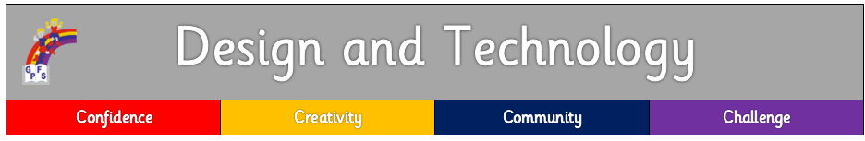

# Purpose of Study

Design and technology is an inspiring, rigorous and practical subject. Using creativity and imagination, pupils design and make products that solve real and relevant problems within a variety of contexts, considering their own and others’ needs, wants and values. They acquire a broad range of subject knowledge and draw on disciplines such as mathematics, science, engineering, computing and art. Pupils learn how to take risks, becoming resourceful, innovative, enterprising and capable citizens. Through the evaluation of past and present design and technology, they develop a critical understanding of its impact on daily life and the wider world. High-quality design and technology education makes an essential contribution to the creativity, culture, wealth and well-being of the nation.

# Aims

At Gosforth Park, we aim to enable our children to:

* develop a questioning and reflective mind by providing a range of exciting and enjoyable activities
* enable their creativity and imagination to flourish
* apply their skills and knowledge to design, make and evaluate innovative products
* come to a deepening understanding of Design and Technology concepts
* work safely and carefully

# Curriculum intent

At Gosforth Park, Design and Technology is an inspiring and practical subject. We encourage all of our children to learn to think and innovate creatively, to solve problems both as individuals and as members of a team. We encourage our children to use their creativity and imagination, to design and make products that solve real and relevant problems within a variety of contexts, whilst considering their own and others’ needs, wants and values. We aim to, wherever possible, link our DT work to other disciplines, such as Mathematics, Science, History, Geography Computing and Art. We provide our children with the opportunity to reflect upon and evaluate past and present design technology, its uses and its effectiveness and actively encourages them to become innovators and risk-takers.

# Teaching and Learning

All children have access to the Early Years Foundation Stage Curriculum and Design and Technology National Curriculum. At Gosforth Park, we use a long-term DT curriculum plan delivered over a two year cycle to ensure that all units are covered. Our plans show the breadth of study as well as how designing, making, evaluating and technical knowledge are embedded within each unit of work. Plans also include the key knowledge for each topic that all children should know. Technological vocabulary is explicitly taught with each unit of work to enable children to articulate DT concepts clearly and precisely.

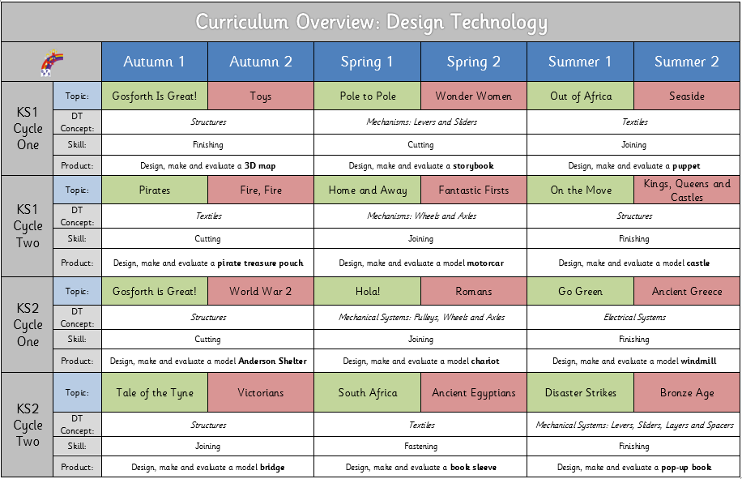

# Curriculum enrichment

We ensure that children have access to a wide range of educational experiences outside of school through trips and links with schools within the Gosforth Schools Trust (GST) and beyond. We celebrate national science week (with a Science, Technology, Engineering and Mathematics focus) annually and invite visitors, speakers, companies leading workshops in order to inspire learning.

# Implementation

All children are taught the skills and principles of Design Technology as outlined in the programmes of study in the National Curriculum for Design Technology. In EYFS, children follow guidelines for creative development as set out in the Early Learning Goals. At key stage one and two, design technology projects are linked to half-termly topics to make learning more meaningful and memorable. Additional to this, creativity is encouraged throughout all subjects. Teachers ensure that investigating and making includes exploring and developing ideas and evaluating and developing work.

Every opportunity is taken for the four key aspects of Design technology to be integrated into learning;

* **Designing**
* **Making**
* **Evaluating**
* **Technical Knowledge**

By the end of each key stage, pupils are expected to know, apply and understand the matters, skills and processes specified in the relevant programmes of study, taken from the National Curriculum.

# Progression

Our Design and Technology curriculum planning enables children to gain a increasingly deeper level of knowledge, understanding and skill competency as they move throughout the school.

* The National Curriculum and Early Years Foundation Stage curriculum objectives are carefully **mapped** and **sequenced** as part of our whole-school curriculum journey.
* Tasks and learning opportunities are planned relating to the **school’s curriculum drivers** (4Cs: confidence, community, creativity and challenge)
* **DT Progression documents** have been developed for Designing, Making and Evaluating. We use these to ensure planning builds upon prior knowledge and skills.
* **Design and Technology concepts** are mapped, taught and referred to in order to deepen understanding within relevant learning units. Concepts help our children to make links between aspects of DT across different contexts and build on their skills and knowledge over time.

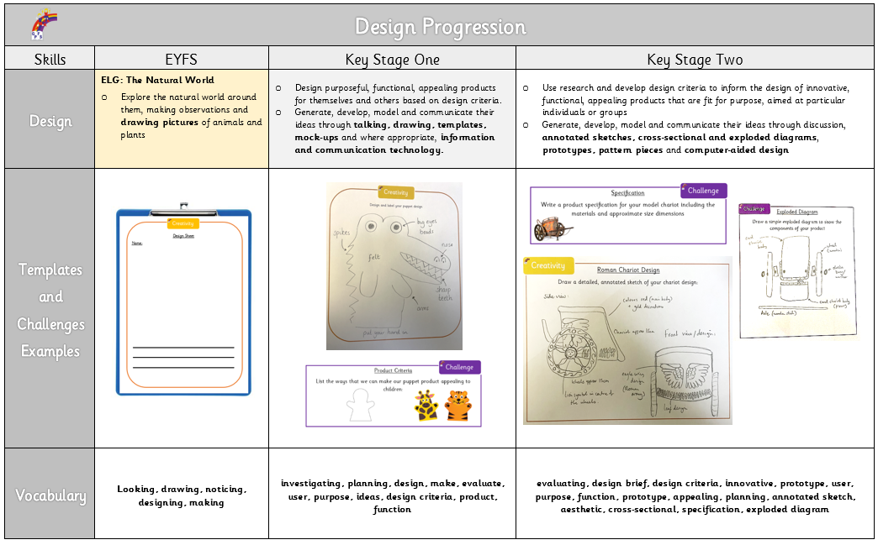

# Records and Assessment

Assessment of children's development is made through a combination of frequent low-stakes quizzing, end of unit evaluation and ongoing teacher assessment. Regular, meaningful feedback is given verbally by teaching staff. Self and peer assessment is used frequently as part of the evaluation process at the end of each learning project. Progress and achievement in Design and Technology is reported to parents through end of year reports and during autumn and spring parent meetings. Success is celebrated within classrooms and as part of our weekly Newsletter.

# Health and Safety

It is important that children are taught the rules of safety when undertaking design and technology. Materials and equipment are handled sensibly and we ensure that children are shown the correct way to conduct activities (e.g. joining, cutting and sawing) so that they can work safely. Children are always closely supervised during ‘making’ lessons. Children are taught how to wear the appropriate safety equipment, such as safety glasses. If children are found to be unsafe, a member of staff will act swiftly to ensure that issues are rectified. It is the teacher’s responsibility to make sure that all helpers (teaching assistants, parents etc.) are aware of safety implications connected with any Design and Technology activity that the children are undertaking.

# Monitoring

The Design and Technology curriculum is monitored regularly by the DT co-ordinator through staff meetings, observation of teaching, monitoring of medium term plans, children’s work and pupil voice.

# Resources

Our DT resources are carefully itemised and regularly audited by our DT Coordinator. Resources are organised according to Key Stage learning projects in order for them to be easily accessible.